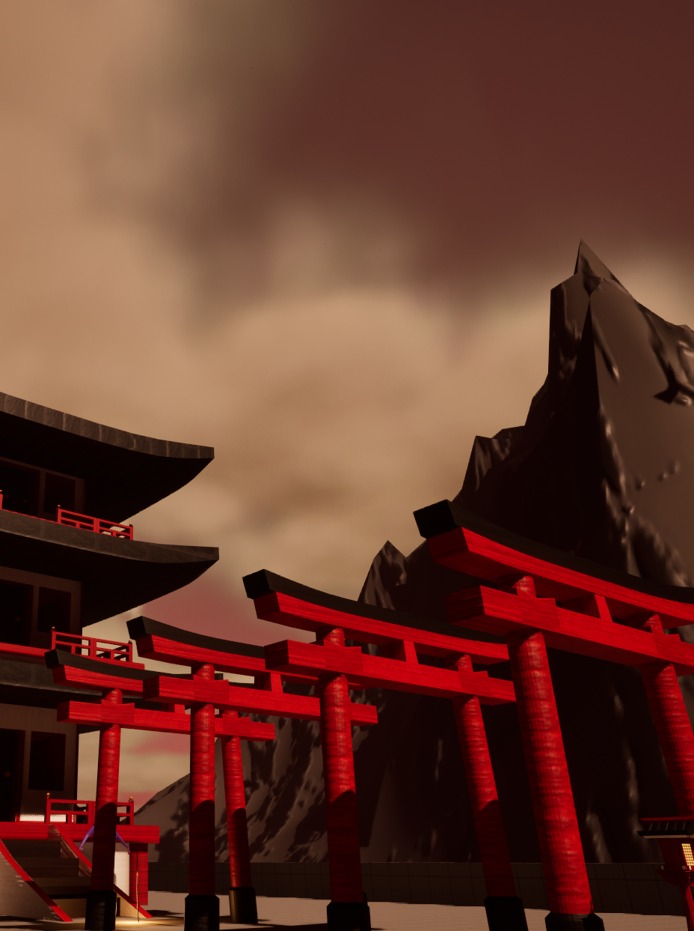

**Jinkonooi**

Written by Dylan Dennis St20231722

Contact Info – [St20231722@cardiffmet.ac.uk](mailto:St20231722@cardiffmet.ac.uk)

Date Of Publishing 15/12/2023

Version Number v1.0

**Table of Contents**

Cover Image………………………………………………………………………………………………………………………………………1

Publishing Details And Title………………………………………………………………………………………………………………..2

Table of Contents……………………………………………………………………………………………………………………………….3

API Versions……………………………………………………………………………………………………………………………………….3

Game Release Build……………………………………………………………………………………………………………………………3

Running the Game……………………………………………………………………………………………………………………………..4

Code Repository…………………………………………………………………………………………………………………………………4

Credits……………………………………………………………………………………………………………………………………………....4

Other IP……………………………………………………………………………………………………………………………………………..4

Issue List…………………………………………………………………………………………………………………………………………….5

**API Versions / Software**

Here is a table of all software and which versions were used to create all facets and features of the game.

|  |  |  |
| --- | --- | --- |
| Name | Version | Software Installer / Purchase Links |
| Blender | 4.0.2 | [Blender 4.0.2 Download](https://www.blender.org/download/) |
| 3DS Max 2024 | 26.2.0.22013 | [3DS Max Purchase](https://www.autodesk.co.uk/products/3ds-max/overview?term=1-YEAR&tab=subscription) |
| Adobe Photoshop 2024 | 25.2 | [Adobe Photoshop Purchase](https://www.adobe.com/uk/products/photoshop.html) |
| Unreal Engine 5 | 5.3.1 | [Unreal Engine Download](https://www.unrealengine.com/en-US/download) |
| Audacity | 3.4.2 | [Audacity Download](https://www.audacityteam.org/download/) |

**Game Release Build**

[Game Download Link](https://drive.google.com/file/d/1X6zgIVAPqooTMuMKhs-bFUs4I9MBAaH6/view?usp=sharing)

**Running The Game**

Video Showing how to download and play the games-built version.

[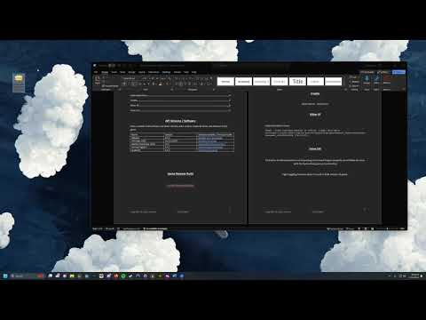](https://www.youtube.com/embed/2ad40iIbUVo?feature=oembed)

**Code Repository**

[Game Implementation Repository](https://github.com/Wmd2452/3D_Modelling_Implementation)

**Credits**

Dylan Dennis - st20231722

**Other IP**

Under Education License

*Vasyl. Young business people in office. [jpeg] Available at:https://stock.adobe.com/uk/search/images?k=people&search_type=recentsearch&asset_id=300144034 [01/12/23].*

**Issue List**

Character model animations not importing into Unreal Engine properly. (most likely an issue with the bones being set up incorrectly)

Light toggling function doesn’t work in built version of game.